
Lab Report
Department: Department of Computer Science and Engineering
Course Title: Computer Networks Lab
Course Code: CSE0612314
Experiment No.: 02
Experiment Title: Routing through hub and switch.

Submitted to:
Teacher’s name: Trisha Sarkar
Designation: Lecturer
Department of CSE
UITS

Submitted by:
Student name: Badhon Kumar Roy
Student Id: 04324205101042
Section: 5A2
Semester: Autumn 2026
Batch: 56th
Date of Submission: 21 August, 2026
Laboratory Report
1. Experiment Number: 02
2. Experiment Title: Routing through hub and switch.

3. Objectives:
- To learn how a hub and a switch handle data communication.
- To understand the difference between hub-based and switch-based networks.
- To design a hybrid network using PCs, a hub and a switch in Packet Tracer.
- To assign IP addresses and test connectivity between devices using CMD ping.
- To observe packet flow through hub and switch using Simulation Mode.

4. Theoretical Background:
A hub and a switch are both networking devices used to connect multiple PCs, but they don't handle data the same way. A hub works at a very basic level — whenever it receives data from one device, it just broadcasts it to every other device connected to it, whether that device needs it or not. This makes hub-based networks slower and less secure as more devices join in. A switch works smarter by learning the MAC address of each connected device and forwarding data only to the specific device it's meant for, which makes communication faster and more reliable. In this experiment, both a hub and a switch were used together in a hybrid setup, so their behaviour could be compared directly by sending test packets and checking connectivity through CMD ping. This kind of comparison makes it easier to understand why switches are used more commonly than hubs in real-world networks.

5. Tools and Software used:
- Cisco Packet Tracer,
- PC-PT,
- Hub-PT,
- 2960-24TT Switch,
- Wires.

6. Network Topology:
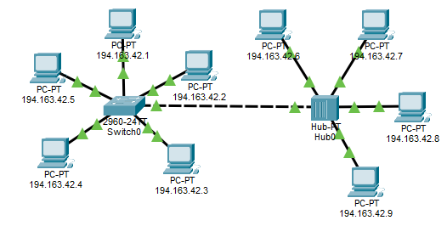
Figure 2.1: Hybrid Topology (PCs connected via Hub and Switch)

7. Methodology:
- At first, we opened Cisco Packet Tracer and set up the workspace.
- Selected required devices like PCs, a Hub and a Switch from the device panel and placed them on the workspace.
- Connected PCs 194.163.42.1, 194.163.42.2, 194.163.42.3, 194.163.42.4 and 194.163.42.5 to the Switch.
- Connected the Switch to the Hub and further connected PCs (PC6, PC7, PC8, PC9) to the Hub.
- Assigned IP addresses to all PCs under the same network using the IP Configuration option.
- Switched to Simulation Mode and sent test packets between PCs connected through the Hub, observing how it broadcasted data to all connected devices.
- Sent test packets between PCs connected through the Switch and observed that it forwarded data only to the intended device.
- Opened the Command Prompt on each PC through the Desktop tab and used the ping command to test connectivity between devices, both across the Hub and across the Switch.
- Took screenshots of the topology, the Simulation Mode results, and the CMD ping results for documentation.
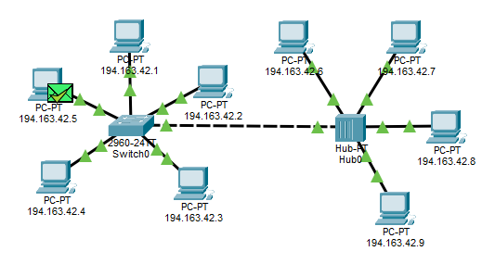
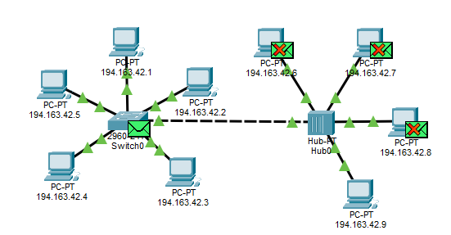
8. Output:
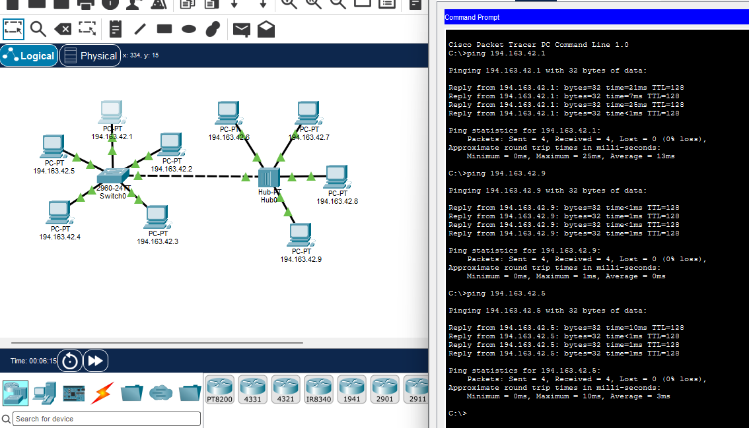
Figure 2.2: Simulation Mode – Packet Broadcast through Hub vs Switch

Figure 2.3: CMD Ping Results for Switch and Hub Connectivity
9. Conclusion:
This experiment helped in understanding the practical difference between a hub and a switch in terms of data communication. While the hub broadcasted data to every connected device, the switch intelligently forwarded data only to the intended recipient, making the network faster and more secure. Testing connectivity through both Simulation Mode and CMD ping made it easier to clearly see this difference in real time. Overall, the experiment gave a solid, hands-on understanding of why switches are preferred over hubs in modern networking.

